Limited Access: Using NCPL’s Genealogy Room to Access Digitized Newspapers & More
Stephanie Clayton, Asst. Genealogist, NCPL

Newspapers not only give us information about world and state news, they also give information about a community as a whole as well as clues for genealogical research. Not only can we find ancestral names associated with a place and date, we find ads for community businesses, marriages, deaths, weather, and other everyday life events. Included here are only a few snippets that anyone can find by visiting the genealogy room of Nelson County Public Library.

- Digitized and Searchable Newspapers including The Kentucky Standard, The Catholic Advocate, as well as previously published papers such as The New Haven Echo and The Nelson County Record. This collection contains issues as far back as the 1800s. Use the accompanying handout for illustrated instructions on using search features with Adobe .pdf.

- Digitized Scrapbooks that contain news clippings from local and other newspapers; photos, and more.

- Subscription to Newspapers.com, free for patrons to explore within the genealogy room.

- Newspaper Abstract Books. These are summaries of news items bound into books here in the Genealogy Room, most of which were compiled by Carolyn Wimp. We have abstract books from Nelson County, Hardin County, Larue County, Breckinridge and Green County, here in the genealogy room. Others include state newspaper abstracts. These abstracts are from papers as early as the 1700s. Other newspaper abstract books we have are 2 volumes of The Kentucky Gazette (1700s-very early 1800s) and Early Louisville, Kentucky Newspaper Abstracts, 1806-1828.

Some Examples:
Nelson County Record- 1 August 1889

- Bloomfield- The Simpson Hotel
Transcription:
Cox’s Creek: George Conner and Judson Taylor
Bardstown: Judge Fulton and Ben Talbott
Taylorsville: George Anderson Mt. Eden: S. Howder, ____Hatches
Louisville: Charles Lieber, Goodloe Searcy, Scott Moore, Ben Johnson, M. C. Wilson, Capt. Keene, Emma Newkirk, Bettie Newkirk.
Smithfield: Dan Buford
Cincinnatti: Ed Southers
Philadelphia: Winder and son

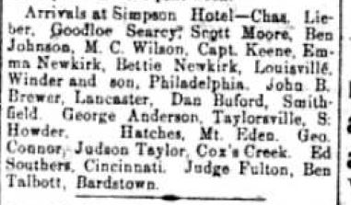
1

Newspaper Abstract Books
Statewide Newspapers, Abstracted and Indexed

Beginning with a Newspaper Abstract book can save time in pinpointing the name of the newspaper, date, and main content. Some of these types of books also include a Placename and Subject Index. Such is the case with the abstracts book, The Kentucky Gazette, 1787-1800. Examples include: Bardstown, Chaplain’s Creek, Saltworks, Nelson County ( 94 entries contained reference to Nelson County), Simpson’s Creek, Distilleries, Rolling Fork, Tobacconists, and many more places and subjects. If an abstract reveals the person, date, or place being sought, it’s always best to view the full article or page, if possible. Also in this book are abstracts of political significance. The entire pages of these newspapers can be viewed on www.newspapers.com. There is a yearly subscription fee or the site can be used, free of charge for library patrons, thanks to a subscription to the site by the Nelson County Public Library. This subscription is only available in the Genealogy Room of NCPL.

Ways to search for specific names or subjects in the digitized newspapers of the genealogy room are varied.
- Narrow your focus to a particular year and just scroll through each issue until you find what you are looking for.
- Beginning with a specific year in mind, follow the written directions posted beside computers # 1 & #2 (or use the accompanying handtout). This may seem time consuming, but once the procedure has been used several times, it gets easier. Hopefully, the many steps to this will yield positive results. One of the genealogists can help with this procedure. * Caveat: The tool for searching these (ocr .pdf) is only about 70% accurate. That means if you think you have the correct year, and the search does not show anything, you may need to change the search term or go back to method 1 from above.
- Search the index of the newspaper abstract books to narrow search. The compiler included all known issues of the newspaper in these books so this may be the best option if you have no idea which year, newspaper, etc…you need. I have solved several brick wall situations using these books prior to searching the actual newspapers.
- Log on to www.newspapers.com and ask one of us for help if needed. Once there, type in a search term, range of dates, and place name. If results do not appear, change the search term, date range, or place name…(or leave the place box blank). Try again.

Finally, be sure to cite any source that you copy, print, or use in your research. This way, you know exactly where you found an item and if you decide to create an article or book, all of your citations can be copied and pasted. Keeping a typed list (Bibliography) of your sources can save time. Copy and paste the citation and edit it for page numbers, etc…in any new document you create.
Example: You wish to create a book to share with family and some of the same books or census records are used for multiple family members. Simply create an ongoing bibliography of resources. If they are already typed then you can simply copy and paste to the new page and you won’t have to type them over and over.

Here are some valuable links to help you cite sources:
https://www.genealogy.com/articles/research/19_wylie.html
https://web.archive.org/web/20140705161451/https://www.progenealogists.com/citationguide.htm

More Samples of valuable search results that can help with genealogy.
- Spencer County-
Taken from the same issue of the Nelson County Record :
In nearby Taylorsville, a resident of the county poorhouse was killed by a handcar in the night.
John Jackson was found lying dead at the foot of the Montgomery trestle, about 1.5 miles north of Taylorsville. A handcar, loaded with people traveling at night from Bloomfield, supposedly knocked Jackson from the trestle in the dark. This is the first death notice I’ve found where the deceased was victim of a handcar.

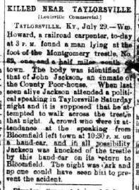

- Bardstown

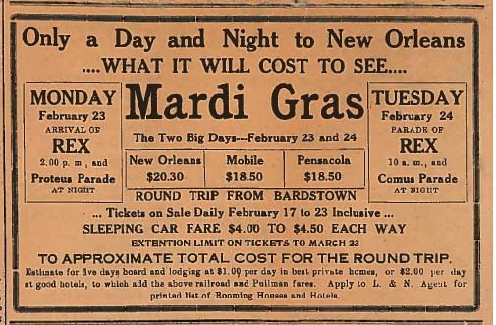
Not sure what to do for Mardi Gras? Go there by train from Bardstown! A round trip to New Orleans would have cost only $20.30. Of course it was advised to estimate additional lodging costs at $1.00 in the best private homes or $2.00 a day in good hotels. The last statement in fine print instructs that the L & N Agent has a printed list of Rooming Houses and Hotels for customers to view. If you had an ancestor living in the area in 1914, this gives you an idea of the costs and means of travel during that year. With enough of items like this, you can begin to get an idea of what life was like for your ancestor.

The Nelson County Record, 1 Aug 1889. Newspapers digital file. Repository, Genealogy Room of Nelson County Public Library, Bardstown, KY.
Karen Mauer Green, The Kentucky Gazette 1787-1800, Genealogical and Historical Abstracts, Gateway Press, Inc., Baltimore, 1983.
Ibid.
The Nelson County Record, 1 Aug 1889. Newspapers digital file. Repository, Genealogy Room of Nelson County Public Library, Bardstown, KY.
The Kentucky Standard, 5 Feb 1914. Newspapers, digital file. Repository, Genealogy Room of Nelson County Public Library, Bardstown, KY..

