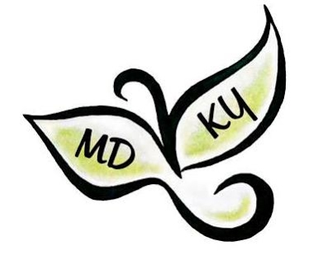
2023 Maryland to Kentucky and Beyond, Inc. Reunion
P. O. Box 1417
Shepherdsville, KY 40165

Website: marylandtokentuckyandbeyond.com
Facebook: https://www.facebook.com/MDtoKYandBeyondInc

FOR IMMEDIATE RELEASE CONTACT: Rhonda Wathen
marylandtokentucky@gmail.com
502-349-81067

The 2023 Maryland to Kentucky and Beyond Reunion is a go – after cancelling for three years due to Covid! It is scheduled for June 9-10, 2023 at Samuels Hall, Nelson County Fairgrounds in Bardstown, KY. Registration, vendors and genealogy sharing are on Friday, June 9. On Saturday, June 10, sessions on Kentucky history and archival records, along with genealogy sharing, vendors, and an evening Banquet, will be held.

The first MD2KY Reunion in 1990 at Nazareth, KY was an opportunity for descendants of the Maryland to Kentucky pioneers to meet and share family history information. The most recent event in 2017 at Brescia University in Owensboro, KY hosted 225 participants from 21 states.

Refer to marylandtokentuckyandbeyond.com for specific event schedules and registration information.

BACKGROUND

In 1785, a group of families from the southern Maryland counties of St. Mary’s, Charles and Prince George’s formed a “Catholic League of Families” (aka “Emigration League”) pledging to migrate to Kentucky.

Reasons for this move were varied. Economics may have played a large role in this westward movement, with the depletion of available land in Maryland and the after-effects of the constant plundering by the British during the Revolutionary War. Religious freedom was certainly a likely concern to many of these pioneers. After a century of anti-Catholic bias in Maryland, many were seeking freedom to openly practice their faith. John Carroll (a few years later named the Bishop of Baltimore) told them that if they would settle together he would do what he could to supply them with a priest.

True to their word, these pioneers largely settled together in what today are the three Kentucky counties of Nelson, Washington and Marion. Even now this central Kentucky area is known far and wide as the Kentucky Holy Lands.

As land further west opened up for settlement, some of these same pioneer families again packed up and headed out seeking a better life for themselves and their families. Many from this group seemed to have agreed once again to settle together. This led to many sister communities of this same group across of the United States.

